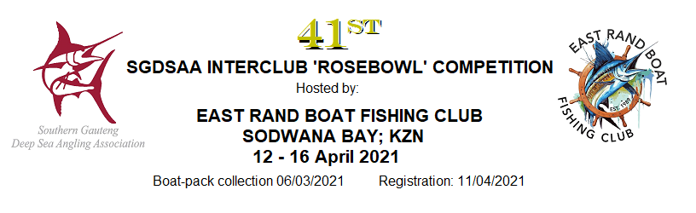
BOAT NAME
BOAT REG No:
CLUB REPRESENTING
SKIPPER’S NAME |  |  |  |  |  |  |  | JUNIOR (u16) |  | LADY
SGDSAA MEMBER? | YES |  | NO |  | SHIRT SIZE |  |  | ENTRY FEE |  | R
POSTAL ADDRESS
EMAIL ADDRESS
TELEPHONE (WORK) |  |  |  |  | CELLPHONE
CREW MEMBER NAME |  |  |  |  |  |  |  | JUNIOR (u16) |  | LADY
SGDSAA MEMBER? | YES |  | NO |  | SHIRT SIZE |  |  | ENTRY FEE |  | R
CREW MEMBER NAME |  |  |  |  |  |  |  | JUNIOR (u16) |  | LADY
SGDSAA MEMBER? | YES |  | NO |  | SHIRT SIZE |  |  | ENTRY FEE |  | R
CREW MEMBER NAME |  |  |  |  |  |  |  | JUNIOR (u16) |  | LADY
SGDSAA MEMBER? | YES |  | NO |  | SHIRT SIZE |  |  | ENTRY FEE |  | R
CREW MEMBER NAME |  |  |  |  |  |  |  | JUNIOR (u16) |  | LADY
SGDSAA MEMBER? | YES |  | NO |  | SHIRT SIZE |  |  | ENTRY FEE
EXTRA NON-ANGLERS |  |  |  |  | @ R400 PER PERSON |  |  | TOTAL |  | R
ENTRY FEE PER ANGLER | R1000,00 PER SGDSAA AFFILIATED MEMBER |  |  |  |  |  | R 1200,00 PER NON SGDSAA MEMBER
FEE PER NON-ANGLER | R400,00 FOR MEALS AT ALL EVENING FUNCTIONS AND DAILY LUNCH
TOTAL NON-REFUNDABLE ENTRY FEE DUE |  |  |  |  |  |  |  |  |  | R

PLEASE RETURN YOUR COMPLETED ENTRY FORM TOGETHER WITH PROOF OF PAYMENT TO:
EAST RAND BOAT FISHING CLUB  CAROL PASCOE  SECRETARY  Email: pascoemw@gmail.com  Cell : 083 296 3662 | EFT payments should be made,  using your BOAT NAME as reference, to:  East Rand Boat Fishing Club  Nedbank (Northmead 194842)  Account no: 194 801 6400
