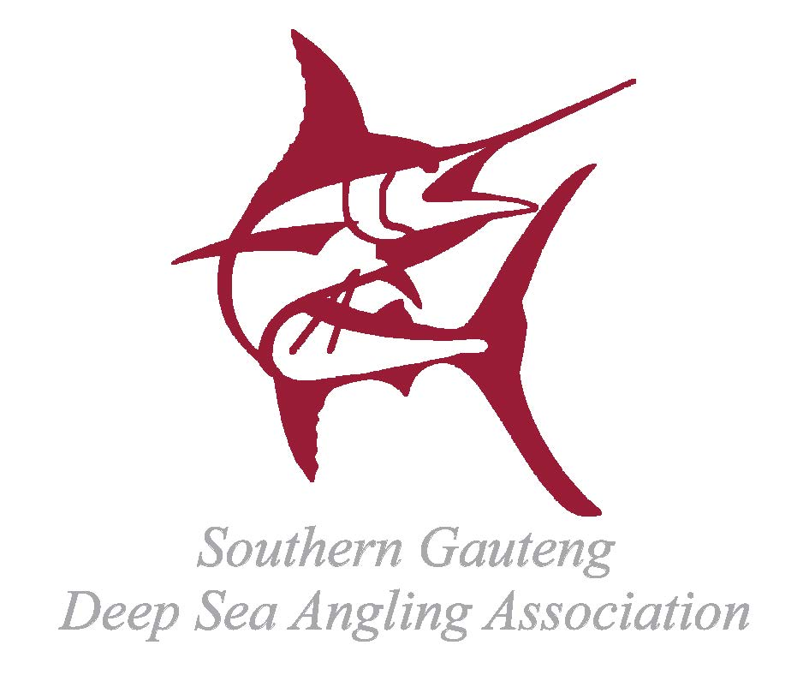


SGDSAA INTERCLUB ‘ROSEBOWL’ COMPETITION
Hosted By
GUINJATA SPORTS FISHING CLUB
GUINJATA BAY, INHAMBANE, MOZAMBIQUE
8 – 13 March 2020
(Registration: Sunday 1st March 2020)
BOAT NAME
BOAT REG No:
CLUB REPRESENTING
SKIPPER’S NAME |  |  |  |  |  |  |  | JUNIOR (u16) |  | LADY
SGDSAA MEMBER? | YES |  | NO |  | SHIRT SIZE |  |  | ENTRY FEE |  | R
POSTAL ADDRESS
EMAIL ADDRESS
TELEPHONE (WORK) |  |  |  |  | CELLPHONE
CREW MEMBER NAME |  |  |  |  |  |  |  | JUNIOR (u16) |  | LADY
SGDSAA MEMBER? | YES |  | NO |  | SHIRT SIZE |  |  | ENTRY FEE |  | R
CREW MEMBER NAME |  |  |  |  |  |  |  | JUNIOR (u16) |  | LADY
SGDSAA MEMBER? | YES |  | NO |  | SHIRT SIZE |  |  | ENTRY FEE |  | R
CREW MEMBER NAME |  |  |  |  |  |  |  | JUNIOR (u16) |  | LADY
SGDSAA MEMBER? | YES |  | NO |  | SHIRT SIZE |  |  | ENTRY FEE |  | R
CREW MEMBER NAME |  |  |  |  |  |  |  | JUNIOR (u16) |  | LADY
SGDSAA MEMBER? | YES |  | NO |  | SHIRT SIZE |  |  | ENTRY FEE
EXTRA NON-ANGLERS |  |  |  |  | @ R400 PER PERSON |  |  | TOTAL |  | R
ENTRY FEE PER ANGLER | R1000,00 PER SGDSAA AFFILIATED MEMBER |  |  |  |  |  | R 1200,00 PER NON SGDSAA MEMBER
FEE PER NON-ANGLER | R400,00 FOR MEALS AT ALL EVENING FUNCTIONS AND DAILY LUNCH
TOTAL NON-REFUNDABLE ENTRY FEE DUE |  |  |  |  |  |  |  |  |  | R
PLEASE RETURN YOUR COMPLETED ENTRY FORM TOGETHER WITH PROOF OF PAYMENT TO:
GUINJATA SPORTS FISHING CLUB  Bradley Padoa  Treasurer  Email : brad@fishguinjata.co.za / info@fishguinjata.co.za  Cell : 082 855 7642 | EFT payments should be made,  using your BOAT NAME as reference, to:  Guinjata Sports Fishing Club  Standard Bank - Springs (012142)  Account no: 637813863

