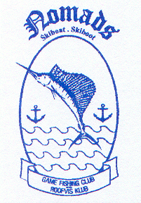 | NOMADS | GAME FISHING CLUB  ROOFVISKLUB
 | Office:  CR Swart Park  Rynfield – 1501  email: nomadsfishing@gmail.com  Website: www.nomadsfishing.co.za |  | Postal:  P.O Box 13899  Northmead  1511

INTER CLUB NOMADS CAPTAIN’S DUTIES

- Liase with team members with regards to tournament.

- Arrange entry, booking of the accommodation, travel arrangements and all information relevant to the tournament.

- The Captain is to make sure that all members have the correct clothing to attend the competition. He must liase with the Nomads Clothing Officer to order any shortages of his team.

- He must have the necessary tackle checks of his team before the competition. If necessary he must organise tackle boxes / training for the team utilising experienced anglers in the club. This can be organised by the Chairman of the club.

- He must within 7 days of completion of the competition submit the Inter Club Competition Report form and expense sheet.

- His team members must complete the Captain’s report and submit to the Chairman of Nomads.

