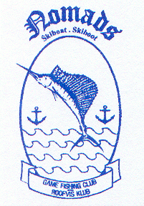 | NOMADS | GAME FISHING CLUB  ROOFVISKLUB
 | Office:  CR Swart Park  Rynfield – 1501  email: nomadsfishing@gmail.com  Website: www.nomadsfishing.co.za |  | Postal:  P.O Box 13899  Northmead  1511

EXPENSES

TEAM / TEAM MEMBER

DETAILS | AMOUNT
Entry
Travelling
Accommodation
Fuel
Bait
Tackle
Clothing
Functions
Food
Beverages
Sundries
TOTAL

