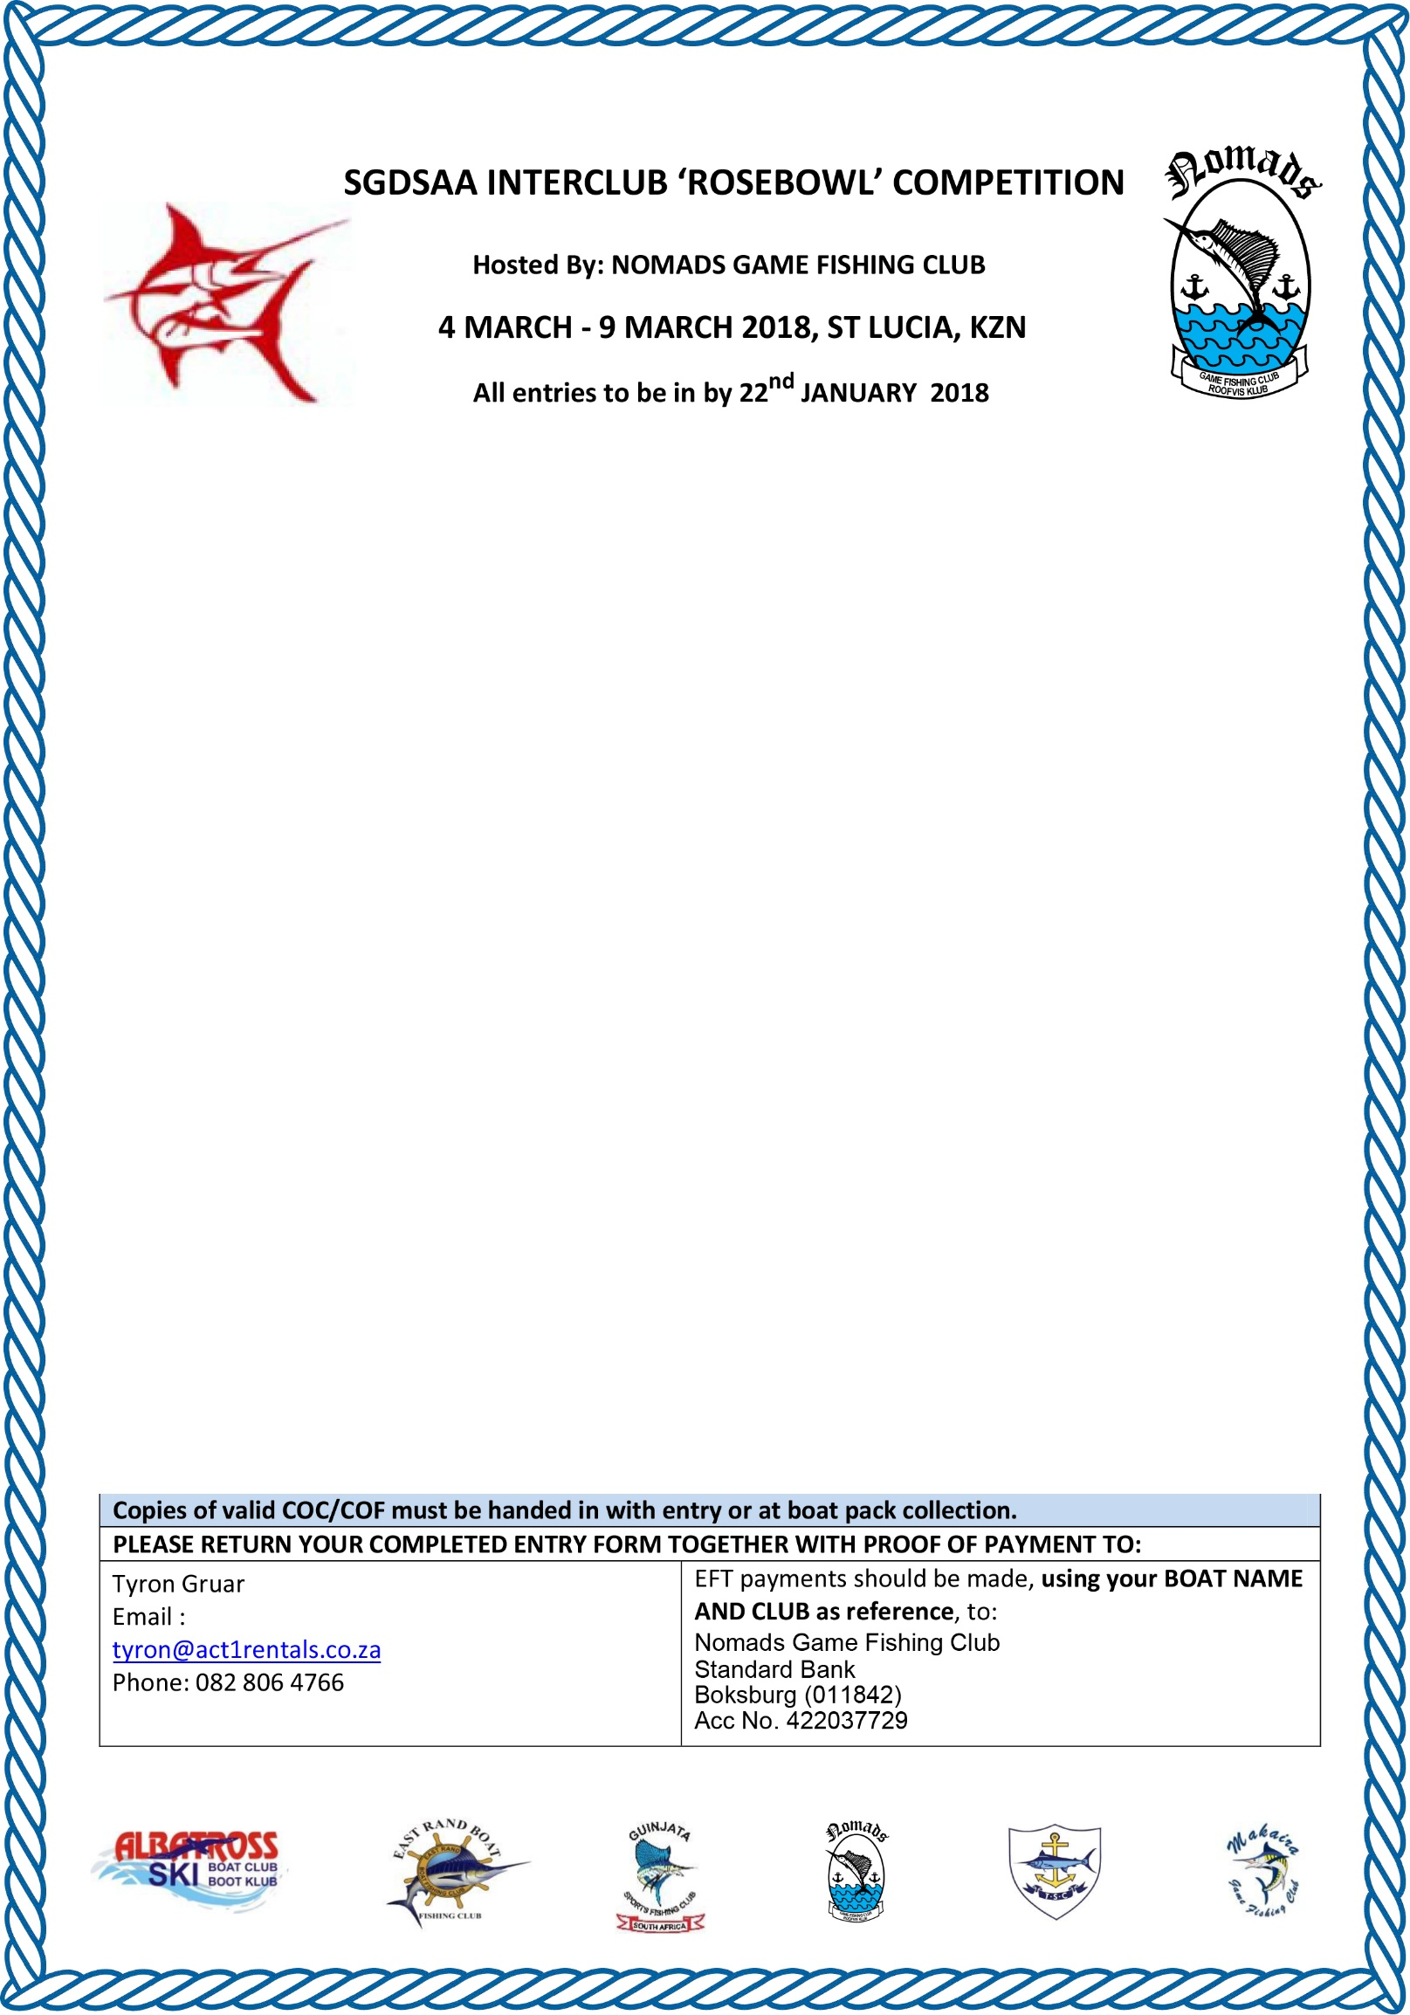

BOAT NAME
BOAT REGISTRATION NO:
BOAT MAKE
CLUB REPRESENTING
SKIPPER’S NAME |  |  |  |  | LADY/JUNIOR: | L | J
SGDSAA MEMBER? | YES | NO | SHIRT SIZE |  | ENTRY FEE | R
POSTAL ADDRESS
EMAIL ADDRESS
TELEPHONE (WORK) |  |  | CELLPHONE
CREW MEMBER (1) NAME |  |  |  |  | LADY/JUNIOR: | L | J
SGDSAA MEMBER? | YES | NO | SHIRT SIZE |  | ENTRY FEE | R
CREW MEMBER (2) NAME |  |  |  |  | LADY/JUNIOR: | L | J
SGDSAA MEMBER? | YES | NO | SHIRT SIZE |  | ENTRY FEE | R
CREW MEMBER (3) NAME |  |  |  |  | LADY/JUNIOR: | L | J
SGDSAA MEMBER? | YES | NO | SHIRT SIZE |  | ENTRY FEE | R
CREW MEMBER (4) NAME |  |  |  |  | LADY/JUNIOR: | L | J
SGDSAA MEMBER? | YES | NO | SHIRT SIZE |  | ENTRY FEE
EXTRA NON-ANGLERS (#) |  |  | @ R600 PER PERSON |  | TOTAL | R
ENTRY FEE PER ANGLER | R1250,00 PER SGDSAA AFFILIATED MEMBER |  |  | R1350,00 PER NON SGDSAA MEMBER
FEE PER NON-ANGLER | R600,00 FOR MEALS AT ALL EVENING FUNCTIONS
TOTAL NON-REFUNDABLE ENTRY FEE DUE |  |  |  |  |  | R

